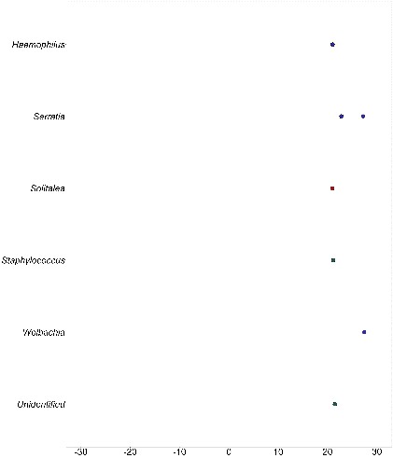

Larval Hydropsychidae

Larval Heptageniidae

Larval Chironomidae

Larval Perlidae

Adult Trichoptera

Adult Diptera

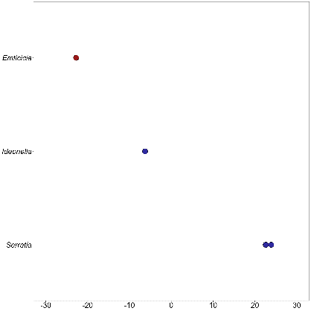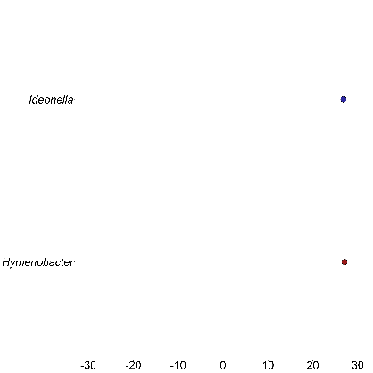

Tetragnathidae

